Tashi Palden

Database Management

Professor Pablo Reevas

April 22, 2016

**Lab 9**

1. Identify and document all functional dependencies.

* League → LeagueID, LeagueName, GamePlayed, Win, Lose, GoalDifference, Points
* Team → TeamID, TeamName, LeagueID, PlayerID, CoachID
* Player → PlayerID, TeamID, FirstName, LastName, Address, Phone
* Coach →CoachID, TeamID, FirstName, LastName, Address, Phone, NoOfYearCoaching

1. Draw a fully annotated E/R diagram that illustrates the platonic ideal of beautiful and correct relational database design.

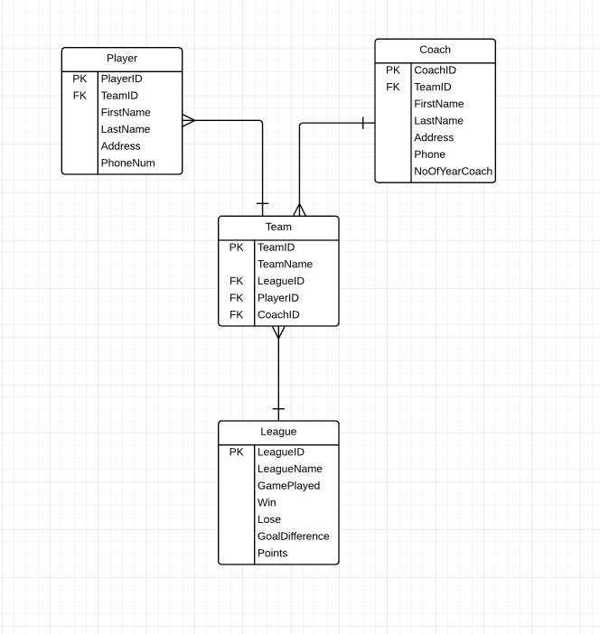

1. Convince me that your database is in 3NF (or even better, in Boyce-Codd Normal Form)

* My database is in 3NF. LeagueID only allow a team to play in one league. A player can only play for one team. A coach can coach several team but each team has to be different league. There’s only one primary key in all the tables.